APPENDIX B

INSTRUCTIONS FOR HANDS-ON EVALUATION (DA FORM 5164-R)

The use of DA Form 5164-R (Hands-On Evaluation) is optional. (See example at Figure B-1, page B-2.) However, it allows the trainer to keep a record of the performance measures a soldier passes or fails on each task. Instructions for using this form are as follows:
Prior to evaluating the soldier--
1. Obtain a blank copy of DA Form 5164-R from AR 350-57. This form may be reproduced locally on 8 ½” by 11” paper.
2. Enter the task title and 10-digit number for the task at the top of the form. You may obtain this information from the evaluation guide of the soldier’s manual task summary.
3. In column “(a)”, enter the number of each performance measure from the evaluation guide.
4. In column “(b)”, enter the performance measure corresponding to the performance measure number in column “(a)”. (You may abbreviate this information if necessary.)
5. Enter the feedback statement from Chapter 1 just below the last performance measure.
6. Locally reproduce the partially completed form if you are evaluating more than one soldier on the task or the same soldier more than one time.
During the evaluation--
1. Enter the date just before evaluating the soldier’s task performance.
2. Enter the evaluator’s name and soldier’s name and unit.
3. For each performance measure, column “(b)”, enter a check in column “(c)” (PASS) or column “(d)” (FAIL), as appropriate.
4. Compare the number of performance measures the soldier passes (and if applicable, which ones) against the task standard shown in the Feedback statement. If the standard is met or exceeded, check the “GO” block under “STATUS.” Otherwise, check the “NO-GO” block.

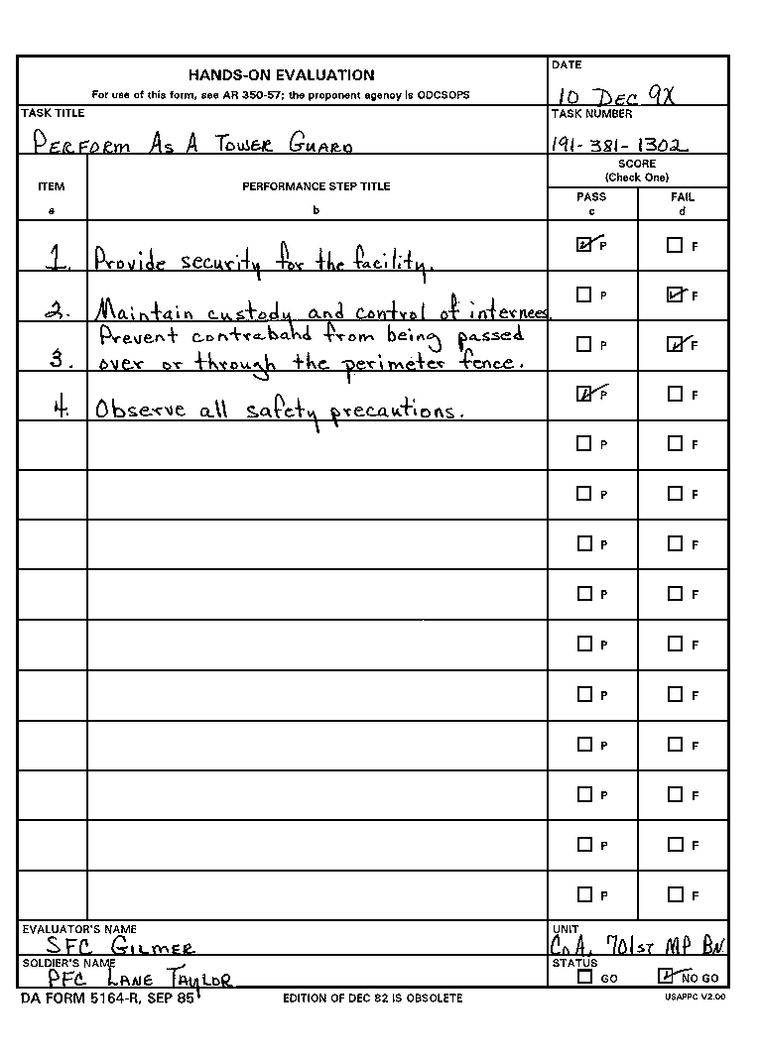
Figure B-1. A completed DA Form 5164-R.

